WEEK 6
Date: |  | Day: MONDAY |  |  | Strand: All Around Us
 |  |  |  |  | Sub Strand: PLANTS -2
Class: KG 2 |  |  | Class Size:
Content Standard:  K2.6.6.1 Demonstrate understanding of how plants grow and how they prepare their food. |  |  |  | Indicator:  K2.6.6.1.7 classify different types of food items according to categories and count the number of objects in each category up to 20.
PERFORMANCE INDICATOR:  - Learners can use a variety of new vocabulary learnt about plants to create an informational text for reading using LEA  - Learners can classify different types of food items according to categories and count the number of objects in each category up to 20. |  |  |  |  | Core Competencies:  Communication and collaboration, Critical thinking, Personal Development and Leadership
Keywords: album,, label, leaves
Reference : KG Curriculum P.g. 173-176
Phase/Duration | Learners Activities |  |  |  |  | Resources
PHASE 1: STARTER | Have learners recite familiar rhymes.  HEY DIDDLE DIDDLE  Hey diddle, diddle  The cat and the fiddle,  The cow jumped over the moon,  The little dog laughed to see such sport,  And the dish ran away with the spoon
PHASE 2: NEW LEARNING  CIRCLE TIME | Teacher, or learner begins by saying "I spy with my little eye something beginning with.....".  The item has to be something within sight of the learners.  Other learners guess until someone guesses correctly. It can also be played with names; "I spy with my little eye someone beginning with..... ".
GROUP ACTIVITY 1  (OUTDOOR) | Using the Language Experience Approach (LEA), create an informational text on Plants give us Food and Medicine.  Learners observe the conversational poster # 19, On the farm and with leading questions, have them create and dictate simple sentences orally and the teacher writes the story for them.  Add few more contents and copy onto a big sheet and use that as a reading text  Provide a variety of fruits, vegetables and seeds.  Have the learners sort and classify them into their three categories. Fruits in one group, seeds and vegetables.  Count the number of objects in each category up to 20.  E.g. guide learners to count the number of food item and pick a numeral card which matches the number quantity.  Teach rhymes and songs as learners sing along  Have learners dance with actions as they sing the songs  Make a choice to use any of the learning centers created |  |  |  |  | Sample young plants, pictures, the Big book, pencils and crayons.
PHONICS | Engage learners to sing songs and recite some familiar rhymes that relates to the target sound.  Guide learners to pronounce and write the target sound in the sand tray or exercise books.  Have learners say three or four words that contain the target sound.  Using flash cards, learners read words that contain the target sound.  1. What sound have we learnt today?  2. Which other letter sound do you know?  3. Mention any object in the classroom or home that begins with the target letter sound. |  |  |  |  | Word cards, letter cards.
GROUP ACTIVITY 2  (INDOOR) | Play music and have each learner grab a balloon when the music starts have learners bounce their balloons in the air and move to the music. When the music stops they have to freeze and whoever is holding a balloon “wins.”  Revise names of parts of plant with learners.  Display a picture of a big plant on the board. Point to the roots and ask learners to call out the name.  Repeat the same activity for the stem, leaves and flowers.  Give out different types of leaves to learners to identify their similarities and differences. Eg. some leaves are broad others are tiny.  Ask: Can you identify a plant whose leave you are holding?”  e.g. “Yes this is a mango leaf”.  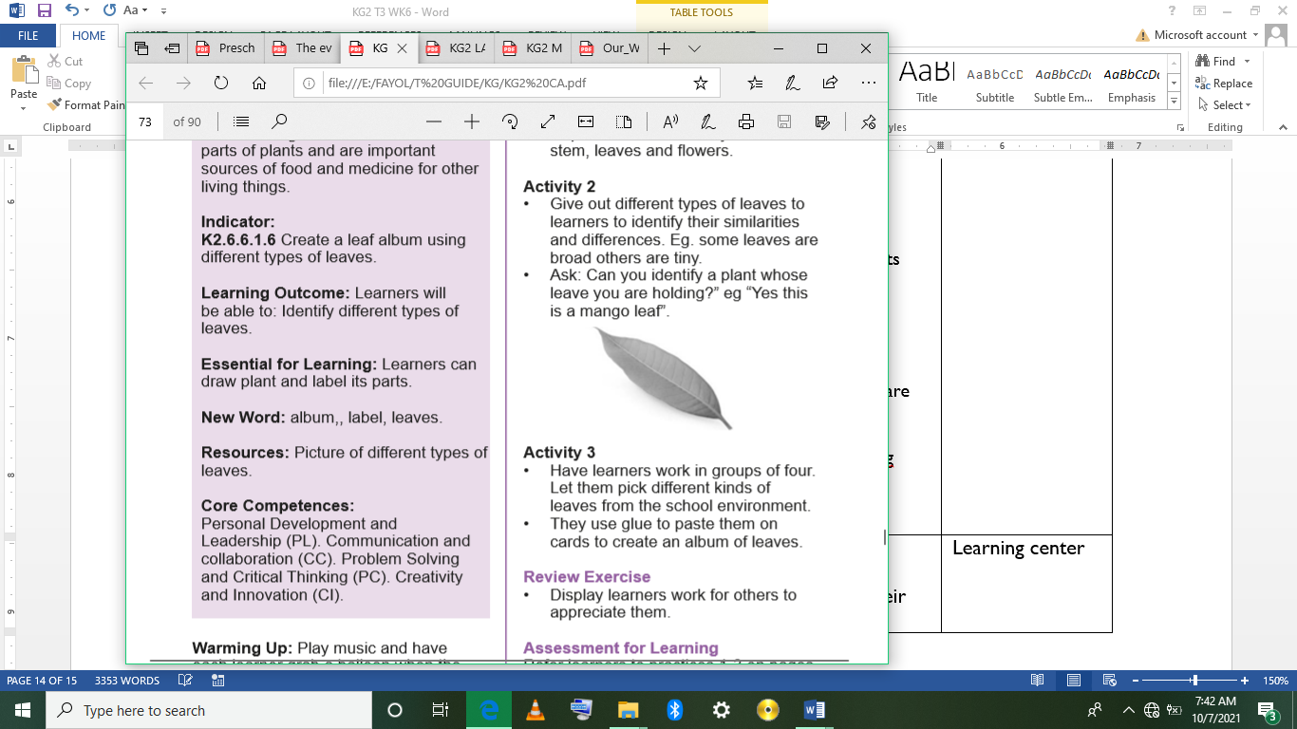  Have learners work in groups of four. Let them pick different kinds of leaves from the school environment.  They use glue to paste them on cards to create an album of leaves.  Assessment  Display learners work for others to appreciate them. |  |  |  |  | Picture of different types of leaves.
LEARNING CENTER | Engage learners to play freely at the learning centers.  Observe, join in and ask learners questions frequently to guide their play and to support their understanding in what they are learning. |  |  |  |  | Learning center
STORY SHARING | Tell learners a story.  Pause regularly and ask questions to make sure learners are following.  Engage learners to act parts of the story.  1. Was the story interesting?  2. What part of the story did you like?  3. what have you learnt from the story? |  |  |  |  | Word cards, letter cards.
PHASE 3: REFLECTION | Learners share what they have learnt with their peers and class.  Teacher sings songs and recite rhymes in relation to the lesson with learners  Give learners homework to do at home.

Date: |  | Day: TUESDAY |  |  | Strand: All Around Us
 |  |  |  |  | Sub Strand: PLANTS -2
Class: KG 2 |  |  | Class Size:
Content Standard:  CONTENT STANDARD:  K2.6.6.1 Demonstrate understanding of how plants grow and how they prepare their food. |  |  |  | Indicator:  K2.6.6.1.6 Create a leaf album using different types of leaves.
Performance Indicator:  - Learners can create a leaf album using different types of leaves. |  |  |  |  | Core Competencies:  Communication and collaboration, Critical thinking, Personal Development and Leadership
Keywords: Plants, roots, leaves, stem.
Reference : KG Curriculum P.g. 173-176
Phase/Duration | Learners Activities |  |  |  |  | Resources
PHASE 1: STARTER | Engage Learners to sing and recite familiar rhymes  WE CAN COUNT  We K1  We can count  We count 1,2,3,4,5  We count 6,7,8,9,10  We K1 can count very well
PHASE 2: NEW LEARNING  CIRCLE TIME | Engage learners to play “Step forward” game.  Learners stand at the start line. Teacher calls out 'if you have a /t/ in your name step forward' or 'if your name begins with /f/ step forward'.  The person to get to the finish line wins.
GROUP ACTIVITY 1  (OUTDOOR) | Teacher reads the Big Book on the theme, answer different levels of questions and use the information to conduct some experiments on why some plants don’t grow well.  E.g. grow plants in a can, put some outside, cover some and hide some in a dark room and find out why some of the plants are not growing well.  Ask learners to pick different kinds of leaves from the school environment and use glue to paste them on cards to create an album of leaves.  Take leaners out of the class to the field for a stretch up. |  |  |  |  | Sample young plants, pictures, the Big book, pencils and crayons.
PHONICS | Engage learners to sing songs and recite some familiar rhymes that relates to the target sound.  Guide learners to pronounce and write the target sound in the sand tray or exercise books.  Have learners say three or four words that contain the target sound.  Using flash cards, learners read words that contain the target sound.  1. What sound have we learnt today?  2. Which other letter sound do you know?  3. Mention any object in the classroom or home that begins with the target letter sound. |  |  |  |  | Word cards, letter cards.
GROUP ACTIVITY 2  (INDOOR) | Take learners outside for “Natures walk”.  Tell them we are going to observe trees and young plants outside.  Let them observe some young and big trees around.  Ask them to up-root some of the young plants. Assist those who cannot pull or better still uproot a lot of young plants for each learner.  Pair learners and give each pair a plant. Ask learners to observe and talk about the plants.  Let them touch and feel the plants.  Note: Be careful of the plants that you give them. Remember the learners have to wash their hands thoroughly with soap under running water after the lesson.  Display a picture of a big plant on the board. Point to the parts one by one and tell learners their names.  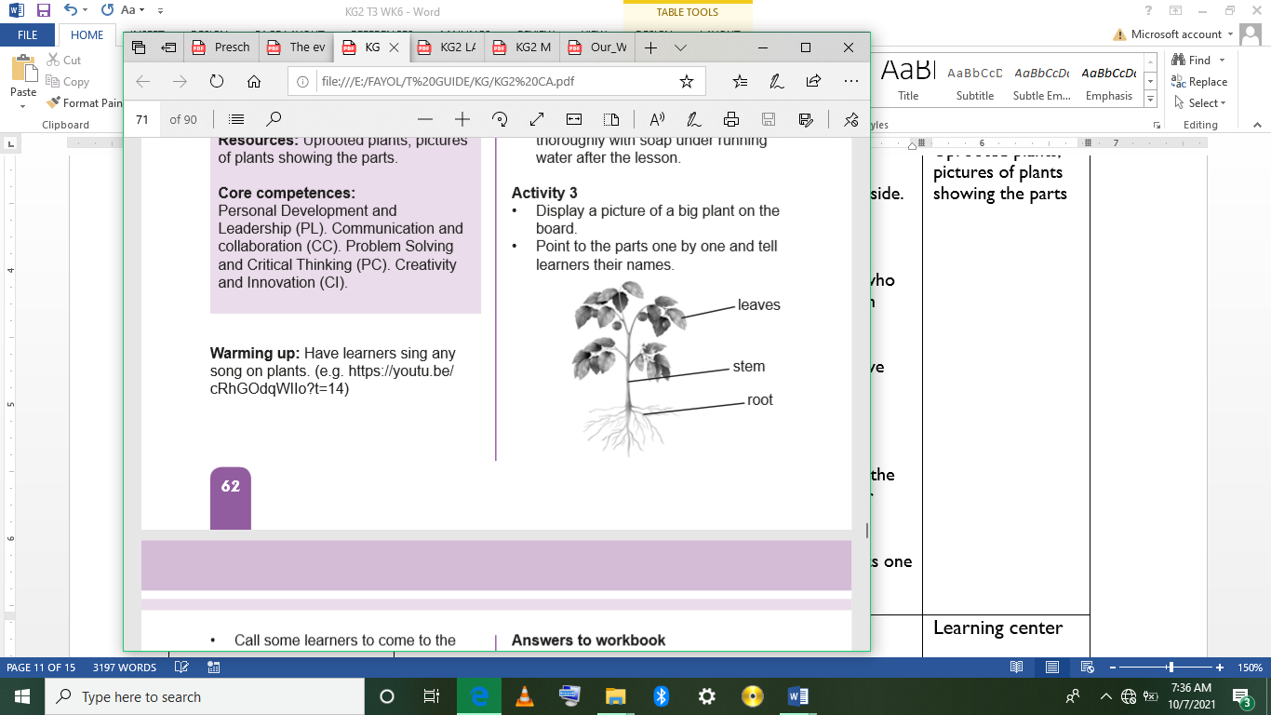  Call some learners to come to the board. Hold a part and they call out its name.  Assessment  Have learners work in pairs. One calls out a part of a plant and the partner touches that part |  |  |  |  | Uprooted plants, pictures of plants showing the parts
LEARNING CENTER | Engage learners to play freely at the learning centers.  Observe, join in and ask learners questions frequently to guide their play and to support their understanding in what they are learning. |  |  |  |  | Learning center
STORY SHARING | Tell learners a story.  Pause regularly and ask questions to make sure learners are following.  Engage learners to act parts of the story.  1. Was the story interesting?  2. What part of the story did you like?  3. what have you learnt from the story? |  |  |  |  | Word cards, letter cards.
PHASE 3: REFLECTION | Learners share what they have learnt with their peers and class.  Give learners homework to do at home.

Date: |  | Day: WEDNESDAY |  |  | Strand: All Around Us
 |  |  |  |  | Sub Strand: PLANTS -2
Class: KG 2 |  |  | Class Size:
Content Standard:  K2.6.6.1 Demonstrate understanding of how plants grow and how they prepare their food. |  |  |  | Indicator:  K2.6.6.1.1 Share ideas about the things (Nutrients) plants need to grow well.
Performance Indicator:  - Learners can share ideas about the things (nutrients) plants need to grow well.  - Learners can create a leaf album using different types of leaves. |  |  |  |  | Core Competencies:  Communication and collaboration, Critical thinking, Personal Development and Leadership
Keywords: fruits, leaves, roots, stem, plants.
Reference : KG Curriculum P.g. 173-176
Phase/Duration | Learners’ Activities |  |  |  |  | Resources
PHASE 1: STARTER | Engage Learners to sing and recite familiar rhymes.  I AM COUNTING ONE  • I’m counting one, what is one  • 1 - One is one alone, alone it shall be.  • 2 - Two pair, two pair come pair let us pair  • 3 - Turn around  • 4 - Follow me  • 5 - Fire  • 6 - Sister  • 7 - Savior  • 8 - Eat more fruits  • 9 - Nana Yaw  • 10 - Thank your God.
PHASE 2: NEW LEARNING  CIRCLE TIME | Follow basic procedures of the community circle time and introduce the theme for the week.
GROUP ACTIVITY 1  (OUTDOOR) | Let learners be in a community circle. Let them play: “Pass the ball”.  Centre time: Have learners grow various plants and put them at different places in the classroom and outside. Put some where there is no sunlight.  Put them into groups of five. Give them plants to grow. Grow some in rocky soil, cover some of the, put some outside, grow some in a good soil, some in the classroom but without any water.  Have students move to the plants and observe them and come back and share their observation  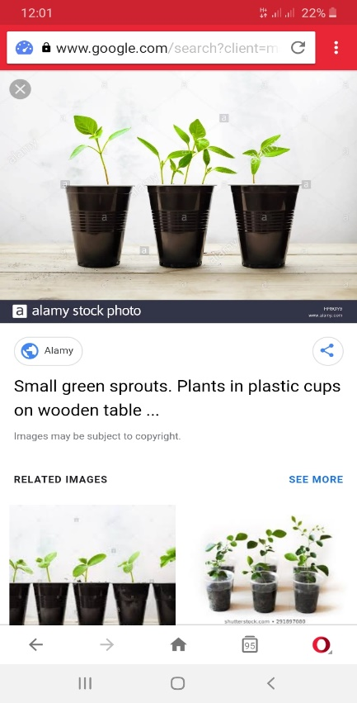  Ask learners to pick different kinds of leaves from the school environment and use glue to paste them on cards to create an album of leaves. |  |  |  |  | Sample young plants, pictures, the Big book, pencils and crayons.
PHONICS | Engage learners to sing songs and recite some familiar rhymes that relates to the target sound.  Guide learners to pronounce and write the target sound in the sand tray or exercise books.  Have learners say three or four words that contain the target sound.  Using flash cards, learners read words that contain the target sound.  1. What sound have we learnt today?  2. Which other letter sound do you know?  3. Mention any object in the classroom or home that begins with the target letter sound. |  |  |  |  | Word cards, letter cards.
GROUP ACTIVITY 2  (INDOOR) | Have learners sing any song on plant.  Greet learners with a smile and let learners do same with friends.  Have learners work in pairs. Display a conversational poster # 19, On the farm and some concrete materials, e.g. small plants, related to the theme, and engage learners in active discussion on the theme for the week using the informational on the poster.  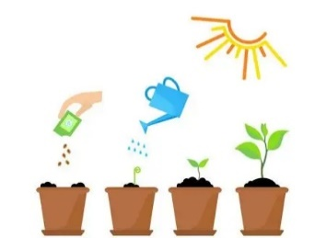  Go for a Nature walk and observe why some plants grow very well but others not.  Back to the classroom, call on learners randomly to contribute to the discussion on what things plants need to grow well. |  |  |  |  | Young plants,
LEARNING CENTER | Engage learners to play freely at the learning centers.  Observe, join in and ask learners questions frequently to guide their play and to support their understanding in what they are learning. |  |  |  |  | Learning center
STORY SHARING | Tell learners a story.  Pause regularly and ask questions to make sure learners are following.  Engage learners to act parts of the story.  1. Was the story interesting?  2. What part of the story did you like?  3. what have you learnt from the story? |  |  |  |  | Word cards, letter cards.
PHASE 3: REFLECTION | Learners share what they have learnt with their peers and class.  Give learners homework to do at home.

Date: |  | Day: THURSDAY |  |  | Strand: All Around Us
 |  |  |  |  | Sub Strand: PLANTS -2
Class: KG 2 |  |  | Class Size:
Content Standard:  K2.6.6.1 Demonstrate understanding of how plants grow and how they prepare their food. |  |  |  | Indicator:  K2.6.6.1.2 use a variety of new vocabulary learnt about plants to create an informational text for reading using LEA  K2.6.61.3 participate actively in the teacher-read-aloud of the LEA text which relates to the theme, and share lessons learnt from the text.  K2.6.6.1.4 blend the letter-sounds learn so far into syllables, read and write the syllables boldly and legibly in their books.
Performance Indicator:  - Learners can use a variety of new vocabulary learnt about plants to create an informational text for reading using LEA  - Learners can participate actively in the teacher-read-aloud of the big book which relates to the theme, and share lessons learnt from the reading. |  |  |  |  | Core Competencies:  Communication and collaboration, Critical thinking, Personal Development and Leadership
Keywords: Plants, roots, leaves, stem.
Reference : KG Curriculum P.g. 173-176
Phase/Duration | Learners Activities |  |  |  |  | Resources
PHASE 1: STARTER | Have learners to sing songs and recite familiar rhymes.  ROUND AND ROUND THE GARDEN  Round and round the garden  Like a teddy bear,  One step, two step,  Tickle you under there
PHASE 2: NEW LEARNING  CIRCLE TIME | Engage learners to play the “Sight word wall ball” game.  Use the markers to write 20-25 sight words on index cards.  Attach the index cards to an outside wall using masking tape, or to an inside wall using painter’s tape. Tape them far enough apart both horizontally and vertically that it’s easy to see which word your learners is aiming at.  Call out one of the words. When your learner locates the word on the wall, let him throw the ball at the correct card. Repeat this until he’s had a chance to try hit all of the words.  Next, let your learner decide which words to aim at. Have him point to and read a word and try to hit it with the ball.
GROUP ACTIVITY 1  (OUTDOOR) | Using the Language Experience Approach (LEA), create an informational text on Plants give us Food and Medicine.  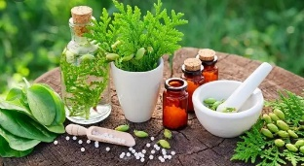  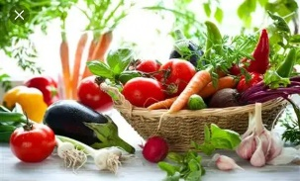  Learners observe the conversational poster # 19, On the farm and with leading questions, have them create and dictate simple sentences orally and the teacher writes the story for them.  Add few more contents and copy onto a big sheet and use that as a reading text.  Follow the steps of the KWL strategy instruction as you read aloud the informational text on the uses of plants to the learners.  Pause often and let learners find answers to their questions.  Learners first say what they know about plants(K),  Ask questions on what they want to know,  Have learners listen to the text and answer their own questions during the reading and share what they have learnt about the parts of a plant and their uses after the reading.  Rapidly revise the letter sounds learnt so far.  Revise previous week’s lesson on blending of two individual sounds to make one syllabic word as done the previous week using pupils blending game.  Teach learners to blend monosyllabic words to form two syllabic words such as Ko-fi, gogo, te-do(tedo), to-lo(tolo), ba-ba (baba) Ama.  Use Pupil blending process as found in K2. 6.3.1.4 to teach blending of two syllabic words.  Call to the front and give one- syllabic word each to 2 learners.  Upon prompting, let them practice creating many mono-syllabic words by gradually moving towards each other sounding out the single syllabic words separately until they come together, put the two syllables together and sound them as one word.  Call on many other learners to practice putting together two monosyllabic words to become one word. {Ko+ fi=kofi, a+fi =afi. Ma+ma =Mama}.  Take Learners out of the class to the field for a stretch up. |  |  |  |  | Sample young plants, pictures, the Big book, pencils and crayons.
PHONICS | Engage learners to sing songs and recite some familiar rhymes that relates to the target sound.  Guide learners to pronounce and write the target sound in the sand tray or exercise books.  Have learners say three or four words that contain the target sound.  Using flash cards, learners read words that contain the target sound.  1. What sound have we learnt today?  2. Which other letter sound do you know?  3. Mention any object in the classroom or home that begins with the target letter sound. |  |  |  |  | Word cards, letter cards.
GROUP ACTIVITY 2  (INDOOR) | As usual, put learners in a community circle. Let them sing the song on plants, clap their hands and dance as well.  Display the roots (cassava, yam, sweet potatoes), fruits (oranges, grapes), leaves on the table.  Call one learner to come and group them into three. i.e. fruits, roots and vegetables.  Show pictures of roots which have produced food to them. Let them touch the yam, cassava and the sweet potatoes.  Deduce from them where we get them from (i.e. from the roots of plants)  Put the vegetables and the fruits on learners table. Let them work in groups of six. They examine and talk about how we get these from. (from plants).  Let them know that some plant makes flowers and the flowers turn to vegetables and fruits.  Give them the leaves to observe. Let them tell you the uses. E.g. Some leaves are used as medicine.  Have learners hold their chairs. Ask them which part of the plant we got it from. (from the stem of plants) so the tables, doors, wooden spoons, etc. are from plants.  Assessment  Put learners into groups of four. Each person mentions two things we get from leaves, stem and root
LEARNING CENTER | Engage learners to play freely at the learning centers.  Observe, join in and ask learners questions frequently to guide their play and to support their understanding in what they are learning. |  |  |  |  | Learning center
STORY SHARING | Tell learners a story.  Pause regularly and ask questions to make sure learners are following.  Engage learners to act parts of the story.  1. Was the story interesting?  2. What part of the story did you like?  3. what have you learnt from the story? |  |  |  |  | Word cards, letter cards.
PHASE 3: REFLECTION | Learners share what they have learnt with their peers and class.  Give learners homework to do at home.

